

KINGSWAY CHRISTIAN COLLEGE
Year 12 ATAR Physics 2017

Task 2
Test: Gravity, Satellites, Motion and Torque.
Name _______________________________________________

Date due: Friday, 17 March 2017
Time allowed 80 minutes
Section A | Available mark | Student mark
Question 1 | 7
Question 2 | 7
Question 3 | 7
Question 4 | 8
Question 5 | 17
Question 6 | 14
Question 7 | 8
Question 8 | 10
Question 9 | 8
Total marks | 86
% | 100

Section A: Short answer questions. Write the answers in the spaces provided.
1. A projectile is fired from position 1 on a very windy day and its path is affected by the wind effects (resistance and drag). The initial velocity is shown as $\vec{u}$.
a) Draw and label on the same diagram, the path the projectile would have taken, if there was no wind. [2]

b) Use arrows to indicate the total velocity and total acceleration at the positions labelled 2, 3, 4, 5 and 6. Point 6 is just before landing. [5]

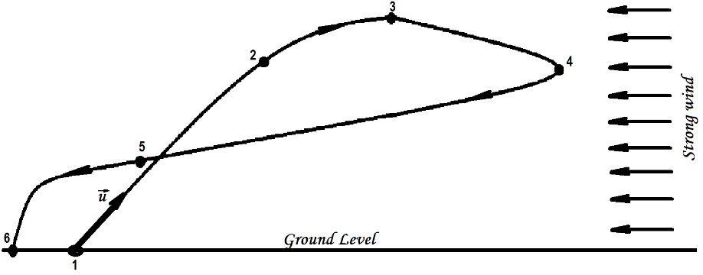

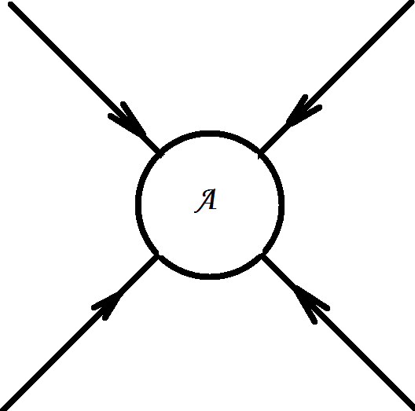
2. a) The gravitational field around an object A with mass m is shown below. Draw the gravitational field for an object B of the same size but with mass 2m. [2]
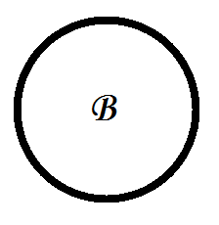

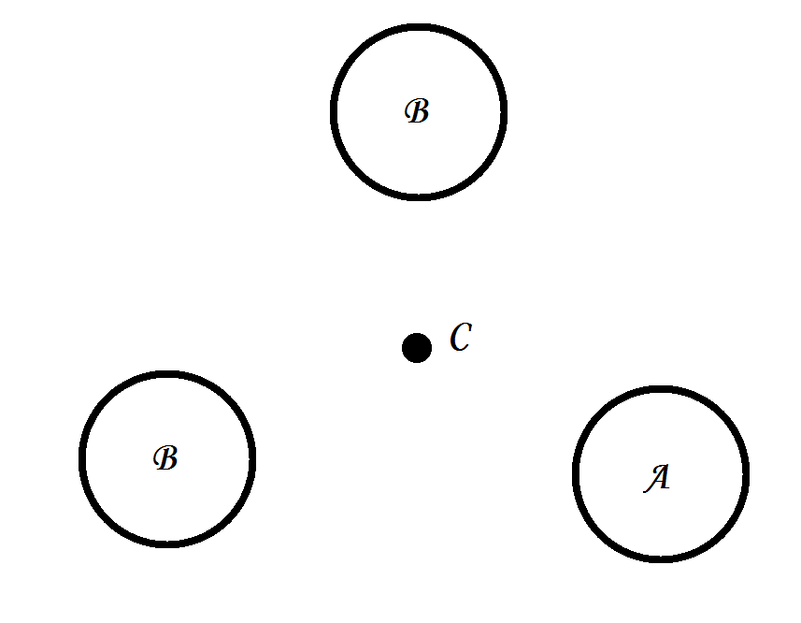
b) Objects A (mass m), B (mass 2m) and C (mass m) are positioned as shown. C at the centre and A and 2 × B at the vertices of an equilateral triangle.
Draw vectors to represent the following:
i) The force on C due to A, [1]
ii) The force on C due to the top B [1]
iii) The force on C due to the bottom B [1]
iv) The resultant force on C due to A and 2 × B. [2]

3. a) Two rowers, who can row at the same speed in still water, set off across a river at the same time. One heads straight across and is pulled downstream somewhat by the current. The other one heads upstream at an angle so as to arrive at a point opposite the starting point. Which rower reaches the opposite side first? [3]

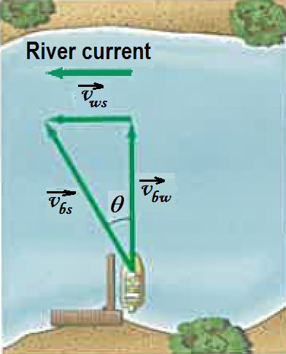
b) A boat that can move in still water with a speed $v_{bw}=1.85 m.s^{-1}$heads directly across the river whose current is $v_{ws}=1.20 m.s^{-1}$.
i) What is the velocity (magnitude and direction) of the boat relative to the shore, $\vec{v_{bs}}$ ? [2]
ii) If the river is 110 m wide, how long will it take to cross and how far downstream will the boat be then? [2]
N

4. Two boxes, m₁ = 1.0 kg with friction = 0.20 times the normal reaction, and m₂ = 2.0 kg with friction = 0.10 times the normal reaction, are attached with an inextensible cord and placed on a plane inclined at θ = 30º .
a) Draw a free body diagram of the forces acting on m₁. [2]

b) Draw a free body diagram of the forces acting on m₂. [2]

c) Write the equations of motion in a direction parallel and perpendicular to the plane and solve for the tension in the cord and the acceleration of the system. [4]

Section B: Problem solving. Answer the questions in the spaces provided. Show all working.
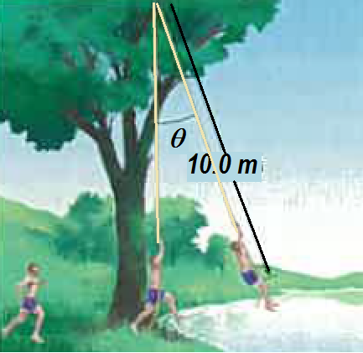
5. a) A 65-kg student runs at 7.0 m.s⁻¹ grabs a rope, and swings out over a lake. He releases the rope when his speed is zero.
i) What is the angle θ when he releases the rope? [2]

ii) What is the tension in the rope just before he releases it? [2]

iii) What is the maximum tension in the rope? [2]

b) A stunt driver wants to make his car jump over eight cars parked side by side below a horizontal ramp.
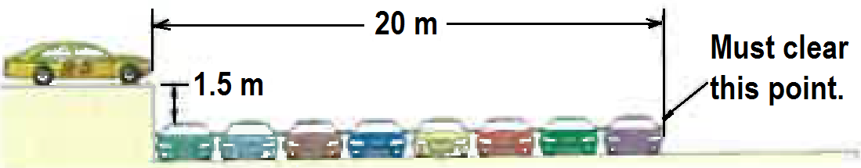
i) With what minimum speed in km.h⁻¹ must he drive off the horizontal ramp? The vertical height of the ramp is 1.5 m above the cars, and the horizontal distance he must clear is 20 m. [3]
ii) If the ramp is now tilted upward, so that ''take-off angle" is 10º above the horizontal, what is the new minimum speed in km. h⁻¹ ? [3]

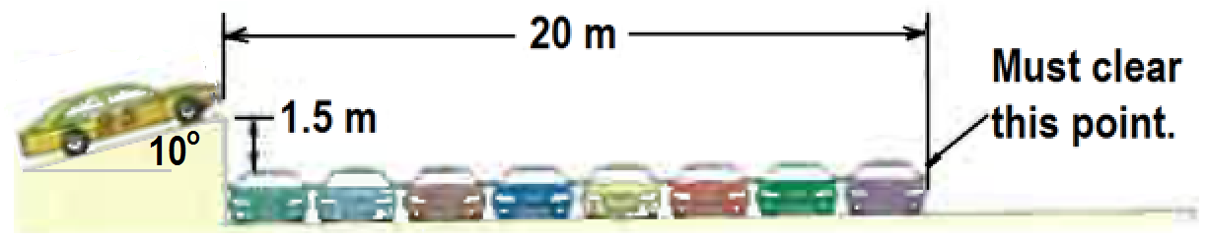

iii) What is velocity of the stunt car as it crosses “Must clear this point.” [3]

iv) What is the maximum height of the stunt car above the top of the lined cars? [2]

6. a) What is the difference between a geosynchronous and a geostationary satellite? [2]

b) Calculate the altitude of a geostationary satellite and give two uses of such a satellite. [3]

c) A 1800 kg satellite is orbiting the earth at an orbital radius of 6.87 × 10⁶ m. Calculate
i) The gravitational force of attraction on the satellite [2]
ii) The gravitational field strength of the earth at the orbit [2]
iii) The acceleration due to gravity of the earth at the orbit [1]
iv) The period of the satellite in this orbit [1]
v) The orbital speed of the satellite [1]
vi) The satellite is to be moved to an orbit with double the period. What will be the new orbital radius of the satellite? [2]

7. A 1500 kg car is negotiating a circular round about with a radius r = 100m. At the instant shown it is heading North at 60 km.h⁻¹.
a) Calculate the sideways friction force, F required to keep the car in circular motion. [2]
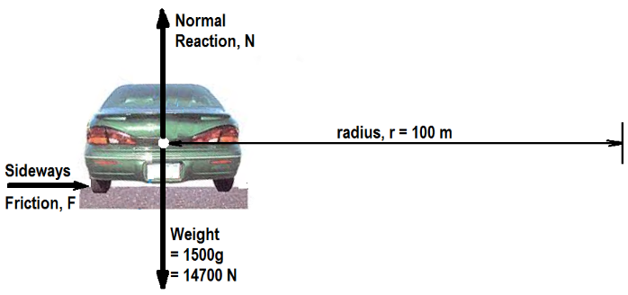

b) The same car is now travelling at optimal speed (no tendency of sideways friction) on a ramp inclined at θ = 30º. The pathway is still circular with radius r = 100 m. Calculate the optimal speed required on this ramp. [2]
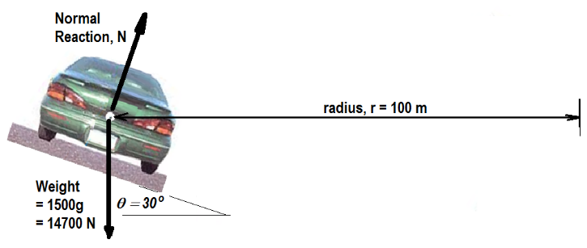

c) The car is still on the 30º ramp and on the circular path with radius = 100 m. However, this time a sideways frictional force of 600 N acts up the slope as shown. Calculate the normal reaction, N and the car speed in km.h⁻¹. [4]
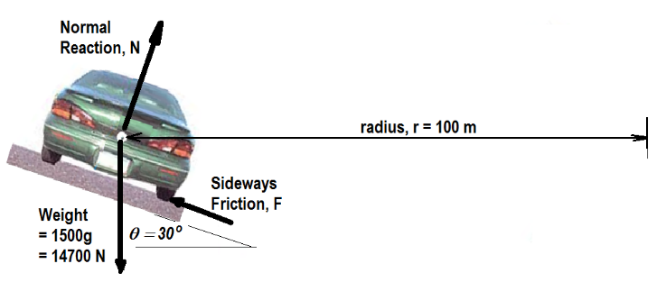

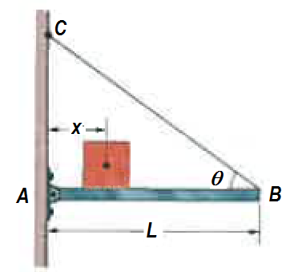
8. a) The length L of the uniform bar is 3.00 m and its weight is 200 N. Also, let the block's weight W = 300 N and the angle θ = 30º. The wire can withstand a maximum tension of 500 N.
i) What is the maximum possible distance x before the wire breaks? [2]
ii) With the block placed at this maximum x, what are the horizontal and vertical components of the force on the bar from the hinge at A? [2]

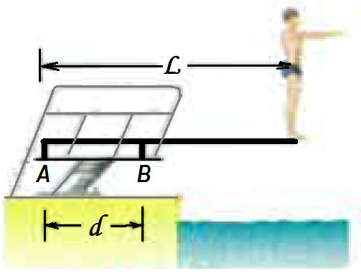
b) A diver of weight 580 N stands at the end of a diving board of length L = 4.5 m and negligible mass. The board is fixed to two pedestals, A and B, separated by distance d = 1.5 m. Of the forces acting on the board, what are the

i) magnitude and direction (up or down) of the force from the left pedestal A. [2]
ii) magnitude and direction (up or down) of the force from the right pedestal, B? [2]
iii) Which pedestal (A or B) is being stretched, and which is being compressed? [2]

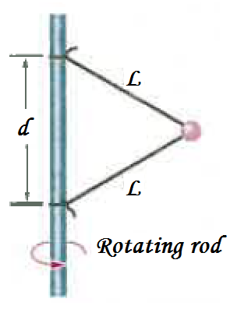
9. A 15.0 N ball is connected by means of two massless strings, each of length L = 2.00 m, to a vertical, rotating rod. The strings are tied to the rod with separation d = 2.00 m and are taut. The tension in the upper string is 1530 N. What are the
a) tension in the lower string, [2]
b) the net force $\vec{F_{net}}$ on the ball, and [2]

c) speed of the ball in m.s⁻¹ and rpm [4]

END of Task 2.

